1. .
   1. .

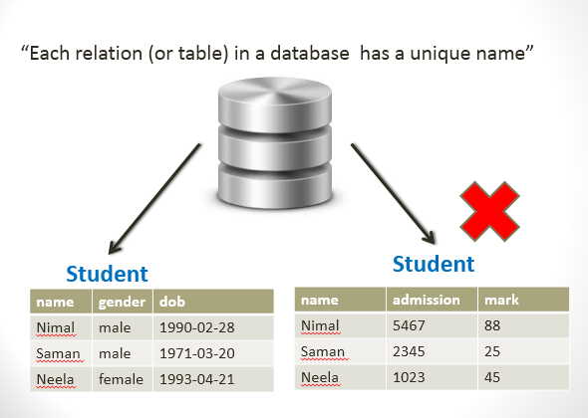

* + 1. .

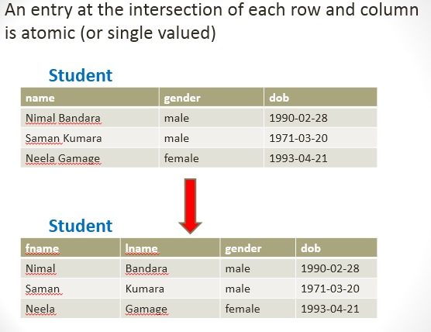

* + 1. .

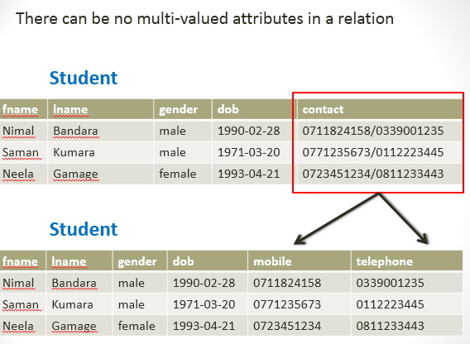

* + 1. .

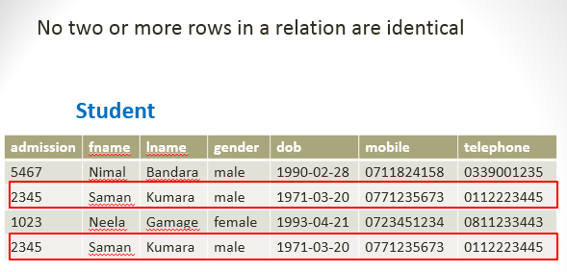

* + 1. .

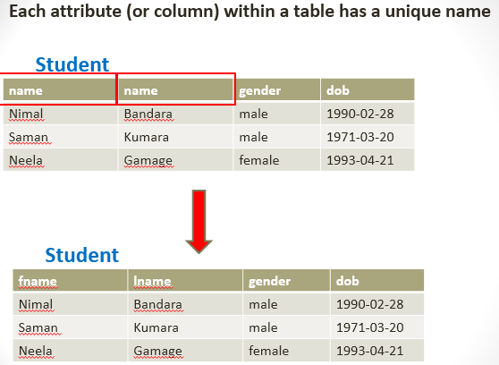

* + 1. .

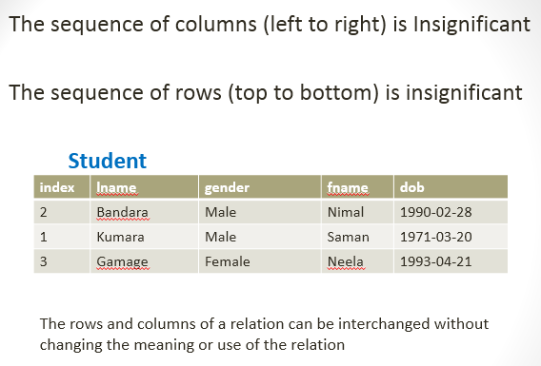

* 1. A set of concepts that can be used to describe the structure of a database
  2. **.**
     1. **Relation** : A table with columns and rows
     2. **Attribute** : A named column of a relation
     3. **Domain** : A set of allowable values for one or more attributes
     4. **Tuple** : A row of a relation
     5. **Cardinality** : Number of tuples of a relation
     6. **Degree** : Number of attributes of a relation
  3. .
     1. A superkey is defined in the relational model of database organization as a set of attributes of a relation variable for which it holds that in all relations assigned to that variable, there are no two distinct tuples (rows) that have the same values for the attributes in this set
        1. {NIC}
        2. {NIC,fName},{NIC,fName,lName}
        3. {NIC,lName},{Email},{NIC,Email}
     2. A primary key is a column (or columns) in a table that uniquely identifies the rows in that table.A candidate key is a column that meets all of the requirements of a primary key. In other words, it has the potential to be a primary key.
        1. {NIC},{Email}
     3. .
        1. A primary key is a column (or columns) in a table that uniquely identifies the rows in that table. And subset of Candidate key.
        2. Any attribute that is a candidate of the primary key but is not a primary key is called an alternate key
  4. .
     1. Entity Integrity :
        1. The primary key for a row is unique; it does not match the primary key of any other row in the table.
        2. The primary key is not null, no component of the primary key may be set to null.
     2. Referential Integrity is the mechanism the system provides to maintain foreign keys. The definition of a foreign key must specify the table whose primary key is being referenced. Referential Integrity ensures only one property for foreign keys.
  5. Relational algebra is a formal language associated with the relational model.
  6. .
     1. Selection: **σ (Sigma)**
     2. Projection: **π (PI)**
     3. Cartesian product: **R x S**
     4. Union: **R ᴜ S**
     5. Set Difference: **R – S**
  7. .

$π\left(sid,fname,lname,age,city\right)\{Student\}$

$π\left(fname,lname\right)\{σ(city=Gampaha)\{Student\}\}$

$π\left(sid\right)\{σ(age<30^city=Kadawatha)\{Student\}\}$

|  |  |
| --- | --- |
| $$π$$ | Projection |
| $$σ$$ | Selection |
| $$∪$$ | Union |
| $$∩$$ | Intersection |
| $$⋈$$ | Join |
| $$÷$$ | Division |
| $$ρ$$ | Rename |
| $$Χ$$ | Cartesian Product |

1. .

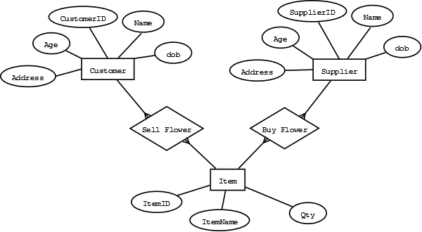

* 1. .
     1. Customer, Supplier
     2. CustomerID, ItemID
     3. Customer Name, Supplier Name
     4. Customer Age,Supplier Age
  2. .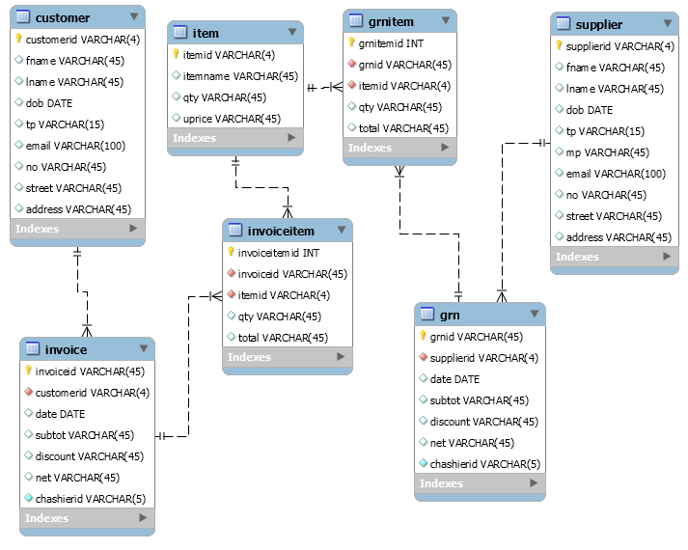
  3. A database is a logically coherent collection of data with some inherent meaning, representing some aspect of real world and which is designed, built and populated with data for a specific purpose.
  4. It is a collection of programs that enables user to create and maintain a database. In other words it is general-purpose software that provides the users with the processes of defining, constructing and manipulating the database for various applications.
  5. The database and DBMS software together is called as Database system.
     1. DBMS Advantages
        1. Redundancy is controlled.
        2. Unauthorised access is restricted.
        3. Providing multiple user interfaces.
        4. Enforcing integrity constraints.
        5. Providing backup and recovery.
     2. File Based System Disadvantages
        1. Data redundancy and inconsistency.
        2. Difficult in accessing data.
        3. Data isolation.
        4. Data integrity.
        5. Concurrent access is not possible.
        6. Security Problems.
  6. The are three levels of abstraction:
* Physical level: The lowest level of abstraction describes how data are stored.
* Logical level: The next higher level of abstraction, describes what data are stored in database and what relationship among those data.
* View level: The highest level of abstraction describes only part of entire database.
  1. It is the number of attribute of its relation schema.
  2. It is an association among two or more entities.
     1. Data Definition Language
     2. Data Manipulation Language

CREATE TABLE `item` (

`itemid` VARCHAR(15) NOT NULL,

`itemname` VARCHAR(45) NULL,

`description` VARCHAR(100) NULL,

`imgurl` VARCHAR(100) NULL,

PRIMARY KEY (`itemid`));

* + - 1. insert into item values('I001','Red Apple','Fruite','C:/Apple.jpg');
      2. update item set itemname=’Orange’,description=’Fruite’,imgurl=’C:/orange.jpg’ where itemid=’I001’;
      3. delete from item where itemid=’I001’;
      4. search * from where itemid=’I001’;

1. l

It is a process of analysing the given relation schemas based on their Functional Dependencies (FDs) and primary key to achieve the properties

(1).Minimizing redundancy, (2). Minimizing insertion, deletion and update anomalies.

* + 1. 1NF
       1. The domain of attribute must include only atomic (simple, indivisible) values.
    2. 2NF
       1. Partial Functional Dependencies have been removed.
    3. 3NF
       1. Transitive Dependencies have been removed.
    4. Multivalued Attribute have been removed

|  |  |  |  |
| --- | --- | --- | --- |
| INVID | Date | CusID | CusName |
| IN001 | 01/01/2015 | C001 | Amal Perea |
| IN002 | 02/01/2015 | C005 | Sunil Nishantha |

Invoice

|  |  |  |  |  |
| --- | --- | --- | --- | --- |
| INVID | ItemID | ItemName | Qty | Total |
| IN001  IN001  IN001 | I2  I4  I5 | Apple  Orange  Grapes | 3  10  0.5 | 180  400  100 |
| IN002  IN002 | I7  I5 | Mango  Grapes | 5  1.5 | 200  300 |

ItemHistory

* + 1. Partial Functional Dependencies have been removed

|  |  |  |  |
| --- | --- | --- | --- |
| INVID | Date | CusID | CusName |
| IN001 | 01/01/2015 | C001 | Amal Perea |
| IN002 | 02/01/2015 | C005 | Sunil Nishantha |

Invoice

|  |  |  |  |
| --- | --- | --- | --- |
| INVID | ItemID | Qty | Total |
| IN001 | I2 | 3 | 180 |
| IN001 | I4 | 10 | 400 |
| IN001 | I5 | 0.5 | 100 |
| IN002 | I7 | 5 | 200 |
| IN002 | I5 | 1.5 | 300 |

|  |  |  |
| --- | --- | --- |
| ItemID | ItemName | uprice |
| I1 |  |  |
| I2 | Apple |  |
| I3 |  |  |
| I5 | Grapes | 200 |
| I7 | Mango | 40 |

ItemHistory Item

* + 1. Transitive Dependencies have been removed

|  |  |  |
| --- | --- | --- |
| 1. INVID | Date | CusID |
| IN001 | 01/01/2015 | C001 |
| IN002 | 02/01/2015 | C005 |

Invoice

|  |  |
| --- | --- |
| CusID | CusName |
| C001 | Amal Perea |
| C005 | Sunil Nishantha |

Customer

|  |  |  |  |
| --- | --- | --- | --- |
| INVID | ItemID | Qty | Total |
| IN001 | I2 | 3 | 180 |
| IN001 | I4 | 10 | 400 |
| IN001 | I5 | 0.5 | 100 |
| IN002 | I7 | 5 | 200 |
| IN002 | I5 | 1.5 | 300 |

|  |  |  |
| --- | --- | --- |
| ItemID | ItemName | uprice |
| I1 |  |  |
| I2 | Apple |  |
| I3 |  |  |
| I5 | Grapes | 200 |
| I7 | Mango | 40 |

ItemHistory Item